“Heaven’s Light is Our Guide”

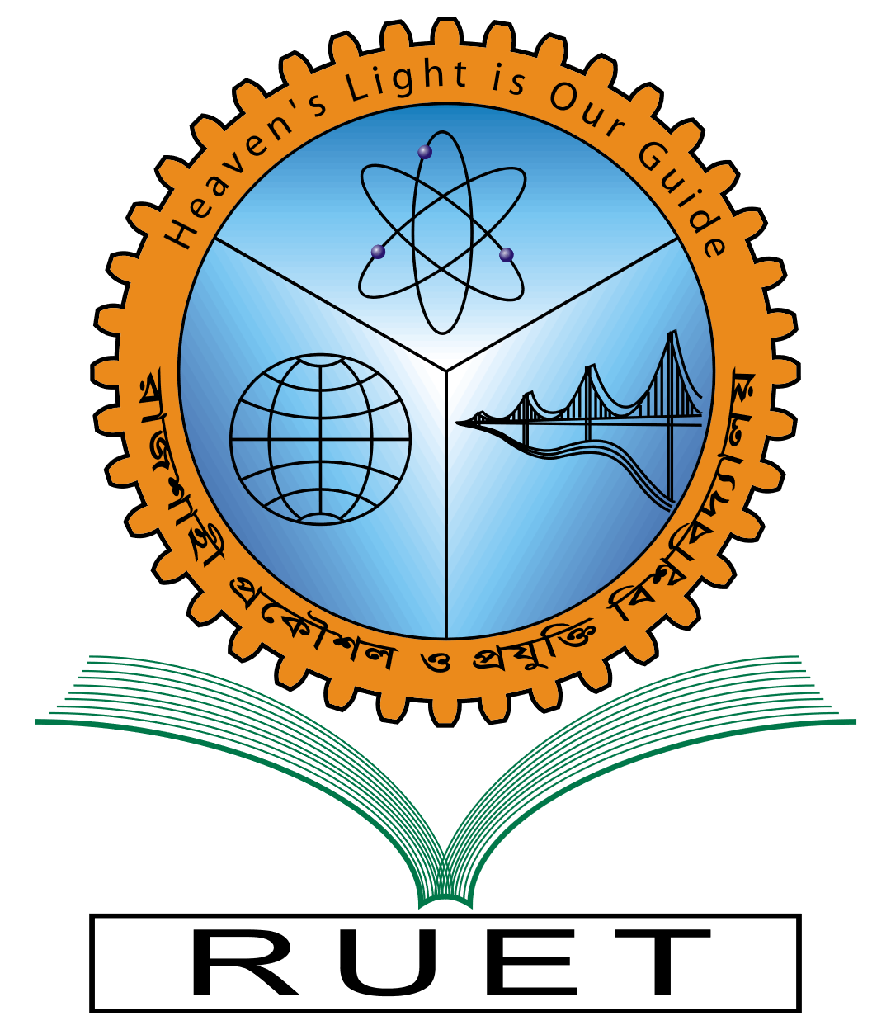

**Rajshahi University of Engineering & Technology**

Department of Computer Science & Engineering

Lab Report

|  |  |
| --- | --- |
| Course Code: | CSE 1202 |
| Course Name: | Data Structure |
| Experiment No: | 1-9 |
| Experiment Name: | Included in Module |
| Date of Experiment: | Every Week |
| Date of Submission: | January 1, 2023 |

|  |  |
| --- | --- |
| Submitted By: | Submitted To: |
| Name: Tonmoy | Md. Shahid Uz Zaman |
| Section: A | Professor |
| Roll: 2003027 | CSE, RUET |
| Year: 1st year, Even Semester |  |